Cal State Los Angeles

PepsiCo Leadership Center

Presents:



“Alternatives to College”


When: Saturday, January 26th, 2008

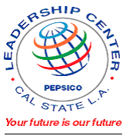

Where: Reiterman House
Time: 9:00a.m. –12:00p.m.

LEARN ABOUT:
• Careers available thru tech schools
• Community colleges vs tech schools
• Admissions requirements
For more information contact:
PepsiCo Leadership Center
California State University, Los Angeles
Library North, Room 1014A
5151 State University Drive
Los Angeles, CA 90032
(323) 343-5270 leadctr@calstatela.edu
• Salaries for tech graduates

ALSO:
• Be mentored by a college student
• PepsiCo snacks will be provided

